**EXPERIMENT 11: CREATION AND EXECUTION OF PROCEDURES**

use db;

show tables;

select * from product;

insert into product values(6,"geitost",3,12);

insert into product values(7,"konbu",4,40);

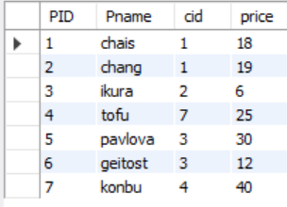

DELIMITER //

create procedure sam(in pnr numeric(33))

begin

select * from product;

end //

create procedure sam1(in pnr numeric(33))

begin

select * from product;

end //

create procedure sam3(in pnr numeric(30))

begin

select * from product where price = pnr;

end //

DELIMITER //

create procedure sam4(out pnr numeric(3))

begin

select count(*) into pnr from product;

end //

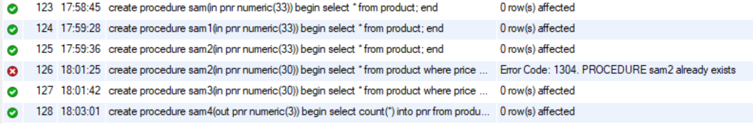

Call sam(33);



Call sam3(33);



Call sam4(@a);



Select @a;

